FOR EXTERNAL USE:
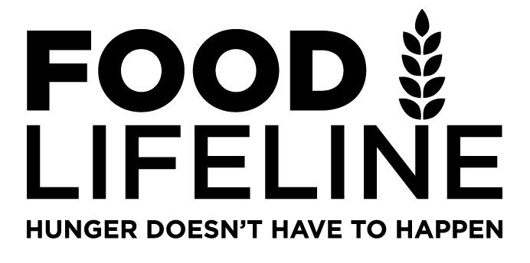
MEDIA
For interviews, testimonials, statistics
and digital assets, contact us:

Shannon Grady Martsolf, Director of Marketing and Communications: shannonm@foodlifeline.org 206.619.6052
Mark Coleman, Chief Media Officer: markc@foodlifeline.org 206.850.3752

ABOUT FOOD LIFELINE:

Our Mission

Food Lifeline’s mission is to feed people experiencing hunger today and working to end hunger for tomorrow.

Tagline
Hunger Doesn’t Have to Happen.

Our Cause
Food Lifeline is on a mission to end hunger in Western Washington. We believe that access to food is a human right. Our goal is to address hunger in two distinct ways: by feeding people who are facing hunger each day, while addressing the root causes of hunger: poverty, racial inequity, and social injustice. It is our firm belief that nobody deserves to be hungry and ending hunger is possible.

The Demand
Hunger and food insecurity doubled since 2020 due to COVID-19. Prior to the pandemic, approximately 850,000 people in Washington experienced hunger every year. That number was estimated to peak to 2.2 million at the height of the crisis. USDA data released in September 2021 suggest one in eight people (14%) are facing hunger. Those same studies indicate Communities of Color disproportionately face food insecurity at twice the rate of the general population, up to two in five Black, Indigenous, People of Color-led households (40%) are at risk for hunger and food insecurity. Since March 2020, food pantries report 40% of current clients are first time visitors. COVID-19 has revealed that for many, food insecurity is often only one paycheck away.

What We Do
Food Lifeline works to fill the immediate food assistance needs of people facing hunger today while working to end hunger for tomorrow by working in partnership with local community-led programs, and state and federal lawmakers, creating long-term solutions focused on hunger’s root causes.

Feeding people today means providing nutritious food to nearly a million people facing hunger in Western Washington annually. We source millions of pounds of donated food from farmers, manufacturers, wholesalers, distribution centers, grocers, restaurants, and retail locations.

Volunteers inspect, sort, and repack food in our 130,000-square-foot Hunger Solution Center. Our multi-pronged distribution model combines Food Lifeline resources, regional distributors, mobile food programs, and relationships with 350 food pantries, shelters, and meal programs throughout Western Washington. Our efficiencies allow us to provide the equivalent of more than 201,000 meals every day to people who don’t have enough to eat.

Feeding people today doesn’t alone solve hunger for tomorrow. The causes of hunger are complex and include geographical, racial, and social inequities that must be addressed. We believe food is a basic human right. To solve hunger for tomorrow, we work with nonprofit partners, government agencies, and legislators. We tirelessly challenge issues of poverty, racial inequity, and social injustice and develop long-term, sustainable strategies to ensure that everybody has enough food to eat.

The Hunger Solution Center is a hub for innovation and partnership that allows our community to join the movement to end hunger.

BACKGROUND & HISTORY:

Food Lifeline’s History:
Food Lifeline has been addressing hunger in the region for more than 42 years. We began in 1979 as “Food Oversight-Operation Distribution,” an organization created in response to Washington State’s need for a central warehouse to accept, store, and distribute large amounts of food that the federal government was distributing to states at the time. Since 1986 we’ve been known as Food Lifeline, a nonprofit leading the fight to end hunger by delivering millions of pounds of food to people facing hunger every year while working in partnership with other organizations. CEO Linda Nageotte has been leading Food Lifeline for more than 20 years.

Food Lifeline Statement:
Food Lifeline is on a mission to end hunger in Western Washington. We believe that access to food is a human right and that nobody deserves to be hungry. Food Lifeline provides nutritious food to hundreds of thousands of people facing hunger every year by sourcing nutritious food from a variety of food industry partners. We distribute this food through a partnership with 350 food pantries, shelters, and meal programs, enabling us to provide the equivalent of more than 201,000 meals every single day. At the same time, we are working to end hunger by addressing its root causes, including systemic inequity and social injustice. We advance our mission through advocacy efforts to shape local, state, and federal policy; by partnering with organizations that are addressing other causes of poverty; and through community engagement and mobilization efforts. Learn more at foodlifeline.org.

How You Can Help:
At Food Lifeline we believe that it will take all of us to end hunger. Everyone has the capacity to give in a way that is both meaningful and impactful. You can give your time volunteering in our Hunger Solution Center. You can become a hunger relief advocate, joining our grass roots efforts to effect change at the local, state, and national level. You can become a contribute financially or through food donations.

Donate: Financial and food donations amplify our impact and reach to abate hunger.
Volunteer: Dedicated volunteers are the heartbeat of our organization.
Advocate: Join our movement to end hunger through policy and community engagement.

