Contact: Mark Coleman @ 206-850-3752 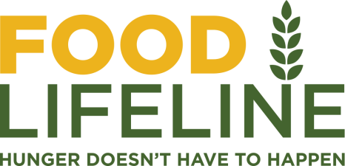
Markc@fll.org
www.foodlifeline.org

Media Advisory: 11//2020
For Immediate Release
Food Lifeline Launches
Season of Giving Campaign
Washington’s largest hunger-relief group begins it’s holiday awareness and fundraising campaign.

November 13, 2020—SEATTLE – Food Lifeline announced today that it’s Season of Giving Campaign will begin as Western Washington braces for increased need during the COVID-19 crisis.

The campaign is aimed at engaging individuals, companies, and groups in providing food to the one in five people that will experience hunger this holiday season.

www.foodlifeline.org/seasonofgiving

More than a dozen large companies are participating in this campaign including
Amazon, Town and Country Markets, Whole Food Market, Procter and Gamble, Mod Pizza, QFC, Les Schwab, KUBE FM, iHeart Radio, Cloudpaper, Delta Dental, Lane Powell LLP, Posie Turner, Full Sail Brewing, Walsh Construction, Molson Coors, E and J Gallo, Continental Mills, McLendon Harware, Pacific Premier Bank, Treasury Wine Estates, and more.

These companies are making gifts, creating employee giving campaigns, retail displays, organizing food drives, and helping raise awareness around the issue of hunger.

The public will also play an outsized role as they engage in crowdfunding and personal giving.

According to Food Lifeline’s President and CEO, Linda Nageotte, this campaign is critical to providing food to more than 1.4 million people in Western Washington that may face hunger this holiday season.

“The need has nearly doubled this year due to the COVID-19 crisis and the massive job losses that have come with it. We’re seeing people in line for food that have never visited a food bank before. We want to make sure that when they show up, we can provide them with the nutritious food they need.”

Food Lifeline’s goal for the campaign is $3 million, which creates the equivalent of 15 million meals.

Individuals and companies wishing to get involved can join Food Lifeline here: www.foodlifeline.org/seasonofgiving

Food Lifeline is also in great need of volunteers to sort and repack the millions of pounds of food that will be donated in the coming months. Sign up here: www.foodlifeline.org/volunteer

People are giving their voice from across western Washington to advocate for programs and policies that work to reduce hunger. To join our grass roots efforts: www.foodlifeline.org/advocacy

Food Lifeline will be announcing events throughout November and December as a part of the campaign, and will provive several opportunities for the media and the public to get involved.

For more on Food Lifeline’s response to the COVID-19 crisis, visit: https://foodlifeline.org/covid-19/

About Food Lifeline

Food Lifeline works to fill the immediate needs of people facing hunger and reduce food insecurity and hunger by creating long-term solutions that are focused on its root causes.

We provide nutritious food to hundreds of thousands of people facing hunger in Western Washington every year. We do this by sourcing millions of pounds of donated food, including fresh produce, from farmers, manufacturers, wholesalers and distribution centers, grocers, restaurants, and retail locations.

Volunteers inspect, sort, and repack food in Food Lifeline’s 130,000-square-foot Hunger Solution Center in Seattle’s South Park neighborhood. We distribute this food through our distribution programs in partnership with 300 food banks, shelters, and meal programs that serve people throughout Western Washington. This highly efficient system allows us to ensure the equivalent of 134,000 meals every day reach people who don’t have enough to eat.
# # #

