Easy Baked Indian Samosas

This has all the flavor and heartiness of a great samosa without the frying. Although this is an easier, healthier version of the fried samosa, it tastes very authentic. This recipe has the added advantage that you can make ahead and freeze uncooked samosas, simply skip the egg brushing, freeze until you're ready and cook at 350 degrees F (175 degrees C) for 25 to 30 minutes. Serve warm, plain, or with chutney.
Prep:
30 mins
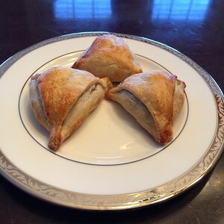

Cook:
40 mins
Additional:
30 mins

Total:
1 hr 40 mins
Servings:
16
Yield:
16 servings

Ingredients
- 4 potatoes, peeled and cubed
- ¼ cup oil
- 2 small onions, finely chopped
- 3 tablespoons coriander seed
- 1 tablespoon curry powder
- 1 (1 inch) piece fresh ginger, grated
- 1 teaspoon salt
- 1 teaspoon ground turmeric
- 1 teaspoon ground cumin
- ½ teaspoon ground allspice
- ½ teaspoon cayenne pepper
- ⅛ teaspoon ground cinnamon
- 2 roma (plum) tomatoes, finely chopped
- ½ cup frozen peas
- 4 prepared pie crusts
- 2 egg whites, beaten, or as needed

Directions
Instructions Checklist
- Step 1
Place potatoes into a large pot and cover with salted water; bring to a boil. Reduce heat to medium-low and simmer until tender, about 20 minutes. Drain and transfer potatoes to a bowl; coarsely mash.
- Step 2
Preheat oven to 400 degrees F (200 degrees C).
- Step 3
Heat oil in a skillet over medium-high heat; cook and stir onions, coriander seed, curry powder, ginger, salt, turmeric, cumin, allspice, cayenne pepper, and cinnamon until onion is lightly browned, about 5 minutes. Remove skillet from heat and stir tomatoes and peas into onion mixture; pour into mashed potatoes and thoroughly mix. Cool completely.
- Step 4
Cut each pie crust into 8 even triangles. Spoon filling onto the wide end of each triangle; fold corners over filling creating a triangular 'hat' shape. Pinch the dough together to form a seal. Brush egg white over each samosa and arrange on a baking sheet.
- Step 5
Bake in the preheated oven until samosas are golden brown, about 15 minutes.

Nutrition Facts
Per Serving:
315 calories; protein 4.9g 10% DV; carbohydrates 32.7g 11% DV; fat 18.7g 29% DV; cholesterol 0mg; sodium 396.2mg 16% DV.

© Copyright 2020 allrecipes.com. All rights reserved.Printed from https://www.allrecipes.com 11/12/2020

