What is William Bridges’ Transition Model?

“Not in his goals but in his transitions man is great.” —Ralph Waldo Emerson

Change and Transition are different.
Change is situational; it is the external event that is taking place, a new strategy, a change in leadership, a merger or a new product. The organization focuses on the outcome that the change will produce, which is generally in response to external events. It can happen very quickly.
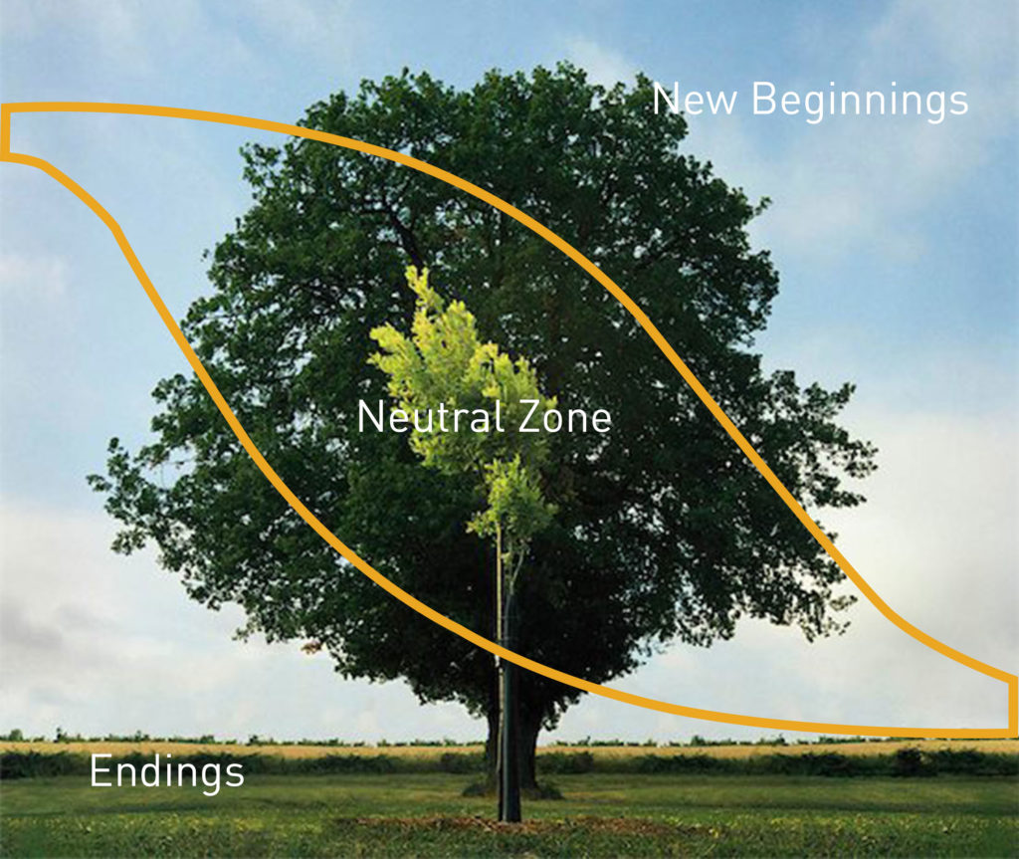
Transition is the inner psychological process that people go through as they internalize and come to terms with the new situation that the change brings about. The starting point for dealing with transition is not the outcome but the endings that people have in leaving the old situation behind. Getting people through transition is essential if the change is actually to work as planned.
https://wmbridges.com/what-is-transition/

Endings
Transition starts with an ending. This is paradoxical but true. This first phase of transition begins when people identify what they are losing and learn how to manage these losses. They determine what is over and being left behind, and what they will keep. These may include relationships, processes, team members or locations.

Neutral Zone
The second step comes after letting go: the neutral zone. People go through an in-between time when the old is gone but the new isn’t fully operational. It is when the critical psychological realignments and repatternings take place. It is the very core of the transition process. This is the time between the old reality and sense of identity and the new one. People are creating new processes and learning what the new roles will be, but it’s in flux and doesn’t feel comfortable yet. It is the seedbed of the new beginnings that are sought.

New Beginnings
Beginnings involve new understandings, new values and attitudes. Beginnings are marked by a release of energy in a new direction – they are an expression of a fresh identity. Well-managed transition allows people to establish in new roles with an understanding of their purpose, the part they play, and how to contribute and participate most effectively. They are reoriented and renewed.

